

TABLE OF CONTENTS

1.Executive Summary
2.Client Overview
3.Reconnaissance Findings
4.Bug Identification
5.Attack Surface Assessment
6.OWASP Risk Mapping
7.Risk Register
8.Recommendations
9.Conclusion

Executive Summary: OWASP Juice Shop Project Overview

Target Audience: CISOs, Security Training Leads, Engineering Directors

1. Context & Purpose
OWASP Juice Shop is an open-source, intentionally vulnerable web application maintained by the Open Worldwide Application Security Project (OWASP). Built entirely on a modern JavaScript stack (Node.js, Express, Angular), it mimics a functional, modern e-commerce platform—making it the industry-standard environment for hands-on application security (AppSec) training, vulnerability demonstrations, and security tool benchmarks.

2. Key Capabilities & Scope
- Comprehensive Vulnerability Coverage: Contains intentionally placed flaws spanning the entire OWASP Top 10 alongside real-world business logic and API vulnerabilities.

- Gamified Learning & Score Board: Features a self-tracking Score Board and interactive "Hacking Instructor" scripts that guide beginners through exploiting flaws and writing code fixes.

- Enterprise Customization & CTF Support: Supports white-label re-branding for corporate environments, integrates seamlessly with CTF platforms, and exports progress metrics via WebHooks/APIs.

[CTF:- “Capture The Flag”
In cybersecurity, a Capture The Flag event or platform is a gamified competition or training exercise where participant solve security challenges (such as finding vulnerabilities, reverse engineering, or exploiting flaws in web applications like OWASP juice shop) to discover a hidden text string called a “flag”.]

- Deployment Flexibility: Containerized (Docker, Vagrant, Node.js) and lightweight, making it easy to host locally or scale on cloud platforms (AWS, Azure, GCP).

3. Strategic Value & Recommendation
Deploying OWASP Juice Shop enables organizations to shift security awareness from passive compliance reading to active, practical skill-building. It provides a safe "sandbox" (It allows developers and security teams toest software or practice hacking safely. If something breaks or get infected, your real production systems remain 100% safe.) for developers to practice defensive coding and for security teams to evaluate SAST/DAST scanner effectiveness without risking live infrastructure.

SAST/DAST:-

Feature | SAST (Static Testing) | DAST (Dynamic Testing)
Testing Approach | White-Box (Inside-out) | Black-Box (Outside-in)
Requires Running App? | No (Scans raw code) | Yes (Interacts with running app)
SDLC Phase | Coding / Build Phase | Staging / QA / Production
Target Area | Source code, dependencies | APIs, web interfaces, server config
Feedback Speed | Fast (Immediate developer feedback) | Slower (Requires full scan execution)
Best For | Finding coding mistakes early | Finding runtime & environment flaws

Quick Comparison TableKey Takeaway: SAST and DAST are complementary, not competing. Modern AppSec programs use both (often alongside SCA for open-source dependencies) to ensure comprehensive security coverage across the entire software lifecycle.

Executive Summary: Mock Security Assessment (Penetration Test)

1. Scope & Engagement
A security evaluation of the OWASP Juice Shop platform was conducted to identify vulnerabilities impacting system confidentiality, integrity, and operational availability. The assessment targeted user authentication, authorization mechanisms, API REST endpoints, and client-side modern components.

API REST ENDPOINTS is a web address provided by a server where an application goes to send or receive data.

2. Risk Profile & Key Findings
The application exhibits a CRITICAL overall risk posture. Numerous high-impact architectural and implementation vulnerabilities permit unauthorized access and complete data compromise.

Severity | Finding Highlights | Business Impact
Critical | SQL Injection (SQLi) in Login Endpoint | Authentication bypass allowing complete administrative account takeover and database exfiltration.
Critical | Broken Access Control & IDOR | Parameter manipulation allows attackers to view/modify other users' shopping baskets and sensitive data.
High | Weak Cryptography & JWT Misconfiguration | MD5 password storage and signature-bypass flaws in JSON Web Tokens enable user impersonation.
Medium | Cross-Site Scripting (XSS) & Input Validation Flaws | Unsanitized inputs enable stored/reflected script execution and business logic exploits (e.g., negative checkout totals).

3.Immediate Action Items

Parameterized Queries: Enforce prepared statements across all database calls to eliminate SQL injection paths.

Access Control Enforcement: Validate token roles and session identifiers server-side for every API request.

Upgrade Hashing & JWT Validation: Replace legacy hashing (MD5) with strong algorithms (Argon2/bcrypt) and strictly enforce JWT signature verification algorithms.

[
JWT stands for JSON Web Token.

It is a compact, URL-safe way of securely transmitting information between two parties (usually a web browser and a server) as a JSON object. I is most commonly used for authentication and authorization.
]

Penetration Testing Phases:-
The 5 Core Phases of Penetration Testing
A professional penetration test follows a structured methodology—most commonly aligned with industry standards like the PTES (Penetration Testing Execution Standard) or OWASP Web Security Testing Guide (WSTG).
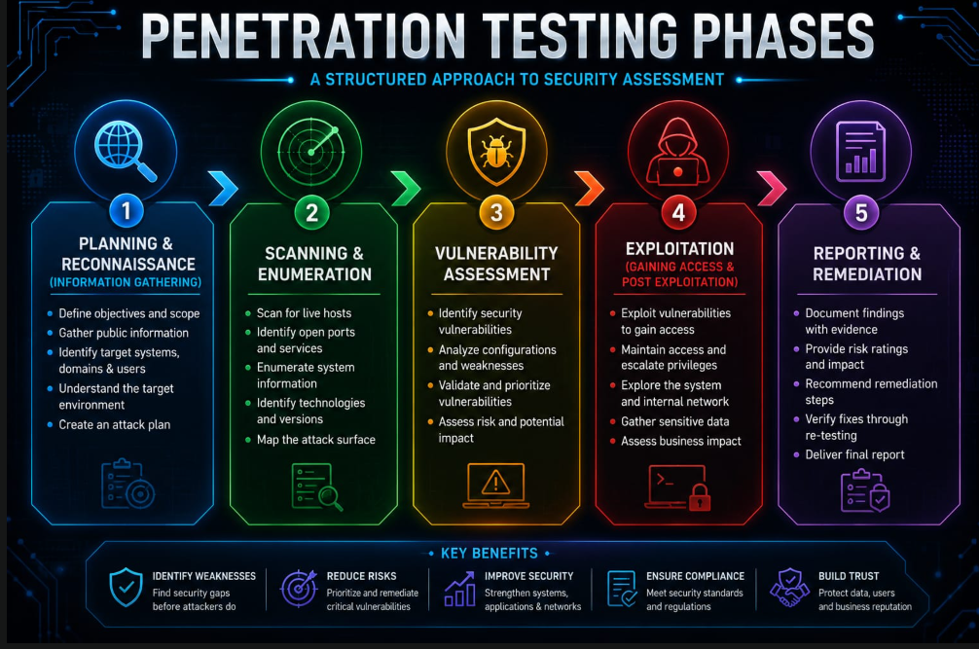

Phase 1: Planning & Reconnaissance (Information Gathering)
Before firing off attacks, the tester defines the rules of engagement and gathers intelligence on the target.
- Passive Reconnaissance: Gathering data without direct interaction with the target system (e.g., searching public repos, OSINT, reviewing tech stacks).
- Active Reconnaissance: Interacting directly with the application/network to map endpoints, technologies, hidden directories, and API routes.
- Juice Shop Context: Finding publicly available endpoints, discovering hidden frontend assets via Developer Tools, or reviewing JavaScript files (main.js) for hardcoded routes.

Phase 2: Scanning & Enumeration
This phase identifies active services, ports, and structural components of the target to map out the full attack surface.
- Network & Port Scanning: Running tools like Nmap or Masscan to detect open ports and running services.
- Directory/Endpoint Brute-forcing: Running tools like Gobuster, ffuf, or Dirbuster to uncover hidden paths (e.g., /ftp, /rest/admin).
- Spidering/Crawling: Mapping out application workflows using proxies like Burp Suite or OWASP ZAP.

Phase 3: Vulnerability Assessment
Testers analyze the discovered endpoints and parameters to identify potential security flaws before attempting full exploitation.
- Automated Scanning: Using vulnerability scanners (OWASP ZAP, Burp Scanner, Nessus) to catch low-hanging fruit.
- Manual Inspection: Testing inputs, headers, authentication flows, and business logic manually.
- Categorization: Mapping identified risks against framework models like the OWASP Top 10 or CWE.

Phase 4: Exploitation (Gaining Access & Post-Exploitation)
In this phase, the tester actively attempts to exploit identified vulnerabilities to validate their severity and real-world impact.
- SQL/NoSQL Injection: Bypassing authentication screens or extracting sensitive database content.
- Broken Access Control & IDOR: Manipulating API payload IDs (e.g., BasketId, UserId) to access other users' private data.
- Cross-Site Scripting (XSS): Injecting malicious scripts into input fields to capture cookies or hijack sessions.
- Privilege Escalation: Elevating standard user access to administrative control (e.g., via JWT token manipulation or parameter tampering).

Phase 5: Reporting & Remediation
The final and most crucial phase where technical findings are translated into actionable business recommendations.
- Executive Summary: A high-level overview of overall risk for management and stakeholders.
- Detailed Technical Findings: Step-by-step reproduction steps (PoCs), severity ratings (CVSS), and impact analysis for developers.
- Remediation Guidance: Clear recommendations on how to patch each vulnerability (e.g., using parameterized queries, setting secure HTTP headers).
- Retesting (Optional): Verifying patches after the development team deploys fixes.

Platform & Service Overview

Key Business Use Cases & Value

Use Case | How OWASP Juice Shop Delivers | Client ROI / Business Value
Developer Security Training | Interactive "Hacking Instructor" mode guides engineers through finding and fixing vulnerabilities directly in the code. | Reduces vulnerability introducing rates early in the SDLC; shifts security left.
Capture-The-Flag (CTF) Events | Built-in CTF key generator integrates seamlessly with CTFd or internal gamification portals. | Boosts employee engagement with practical, gamified security awareness.
Security Tool Benchmarking | Serves as a target to evaluate SAST, DAST, and API security scanners (e.g., ZAP, Burp Suite). | Validates scanner detection rates and eliminates false positives on modern SPAs.
Corporate Customization | Re-branding engine allows customization of logos, themes, and product inventory. | Provides white-labeled training tailored to internal enterprise branding.

Technical Highlights:-

- Modern Stack Realism: Mirrors real-world enterprise architectures using an Angular frontend, Node.js/Express backend, and JSON Web Token (JWT) authentication.

- Vulnerability Breadth: Covers the entire OWASP Top 10, business logic flaws, cryptographic weaknesses, and API security risks.

- Gamified Progress Tracking: Features a self-tracking Score Board that notifies users upon successfully identifying or patching vulnerabilities.

- Self-Healing & Lightweight Deployment: Can be spun up in seconds using Docker or major cloud providers (AWS, Azure, GCP). Resets automatically on restart without data pollution.

Key takeaway:
Traditional security compliance training relies on passive slide decks. OWASP Juice Shop provides an interactive environment where development and security teams build real defensive capability through practical exercise.

RECONNAISSANCE FINDINGS

In a security assessment or penetration testing report, the Reconnaissance Findings section details the information an attacker (or security evaluator) can gather about an organization or application before attempting any exploitation.

It is the process of collecting as much information as possible about a target organization, it’s network, and its applications before launching an attack or security test.

Here is a structured client-ready template and overview of how Reconnaissance Findings are presented in an executive or technical deliverable.

Sample Report Section: Reconnaissance Findings

1. Executive Summary of Reconnaissance
During the initial reconnaissance phase, security testers perform passive and active information gathering to map the target's attack surface. The goal is to identify exposed metadata, system architecture details, leaked credentials, and misconfigured public-facing assets that could be leveraged in downstream attack phases.

2. Reconnaissance Summary Table

Finding Category | Severity | Discovery | Business Risk
Information Disclosure | Low | Server headers and stack versions exposed (e.g., Express, Node.js, SQLite). | Helps attackers tailor specific exploits for running software versions.
Exposed Metadata & Artifacts | Low / Med | Source maps (.map files) or publicly accessible .git directories. | Allows full frontend source code reconstruction and API endpoint mapping.
Subdomain & Asset Mapping | Informational | Staging and API endpoints exposed to the public internet without IP whitelisting. | Increases attack surface and exposes non-production environments.
Credential & Leak OSINT | Medium | Stale developer API keys or corporate email addresses found in public code repositories. | Potential initial access vector via credential stuffing or social engineering.

3. Detailed Breakdown of Reconnaissance Areas

A. Technology Stack Mapping (Banner Grabbing)

- What Was Found: Application headers, error messages, or client-side assets explicitly reveal underlying frameworks, library versions, and database engines.

- Impact: Provides potential adversaries with exact software version numbers, allowing them to cross-reference known public vulnerabilities (CVEs).

B. Source Code & Endpoint Discovery

- What Was Found: JavaScript client bundles expose unlinked REST API endpoints, internal staging URLs, or administrative console paths.

- Impact: Enables attackers to map out hidden functionality and business logic without interacting with administrative interfaces directly.

C. Public Repositories & OSINT (Open Source Intelligence)

- What Was Found: Publicly accessible code repositories or developer commits containing internal environment names, configuration files, or sensitive comment threads.

- Impact: Discloses internal naming conventions, employee roles, and potential security mechanisms in place.

4. Key Remediation & Hardening Guidelines
To minimize the information exposed during the reconnaissance phase, consider implementing the following defensive controls:

- Disable Informational Headers: Suppress version-revealing headers (such as X-Powered-By, Server, or framework signatures) across all web servers and API gateways.

- Remove Client-Side Debug Artifacts: Ensure production build pipelines strip source maps (.map files), verbose console logs, and internal comments.

- Restrict Non-Production Assets: Place staging, testing, and internal administrative interfaces behind a VPN, zero-trust network access (ZTNA), or strict IP allowlists.

- Automate Secret Scanning: Implement automated repository scanners (e.g., GitGuardian, Trufflehog) in CI/CD pipelines to prevent accidental commit of API keys or sensitive configurations.

BUG IDENTIFICATION

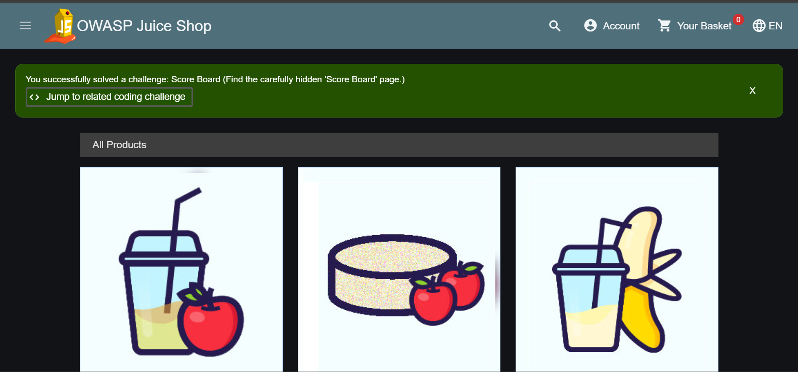
Figure1- Main Page

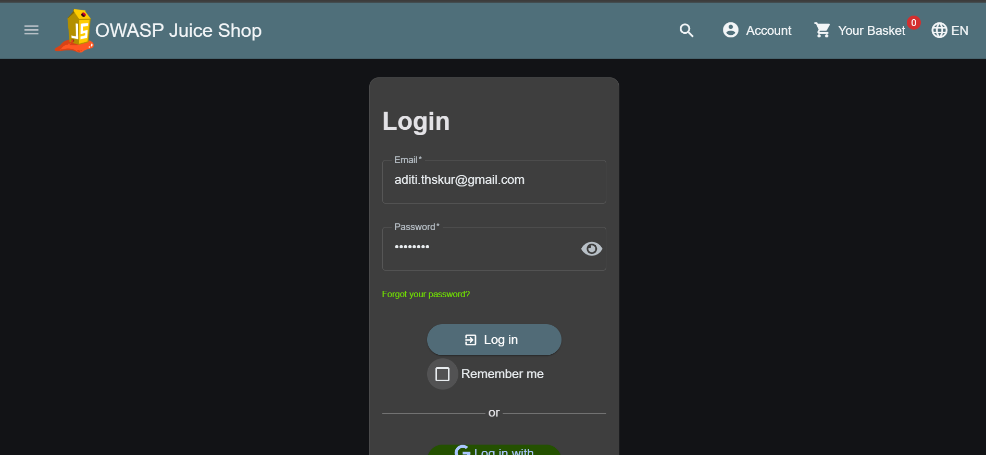
Figure2- login was not done

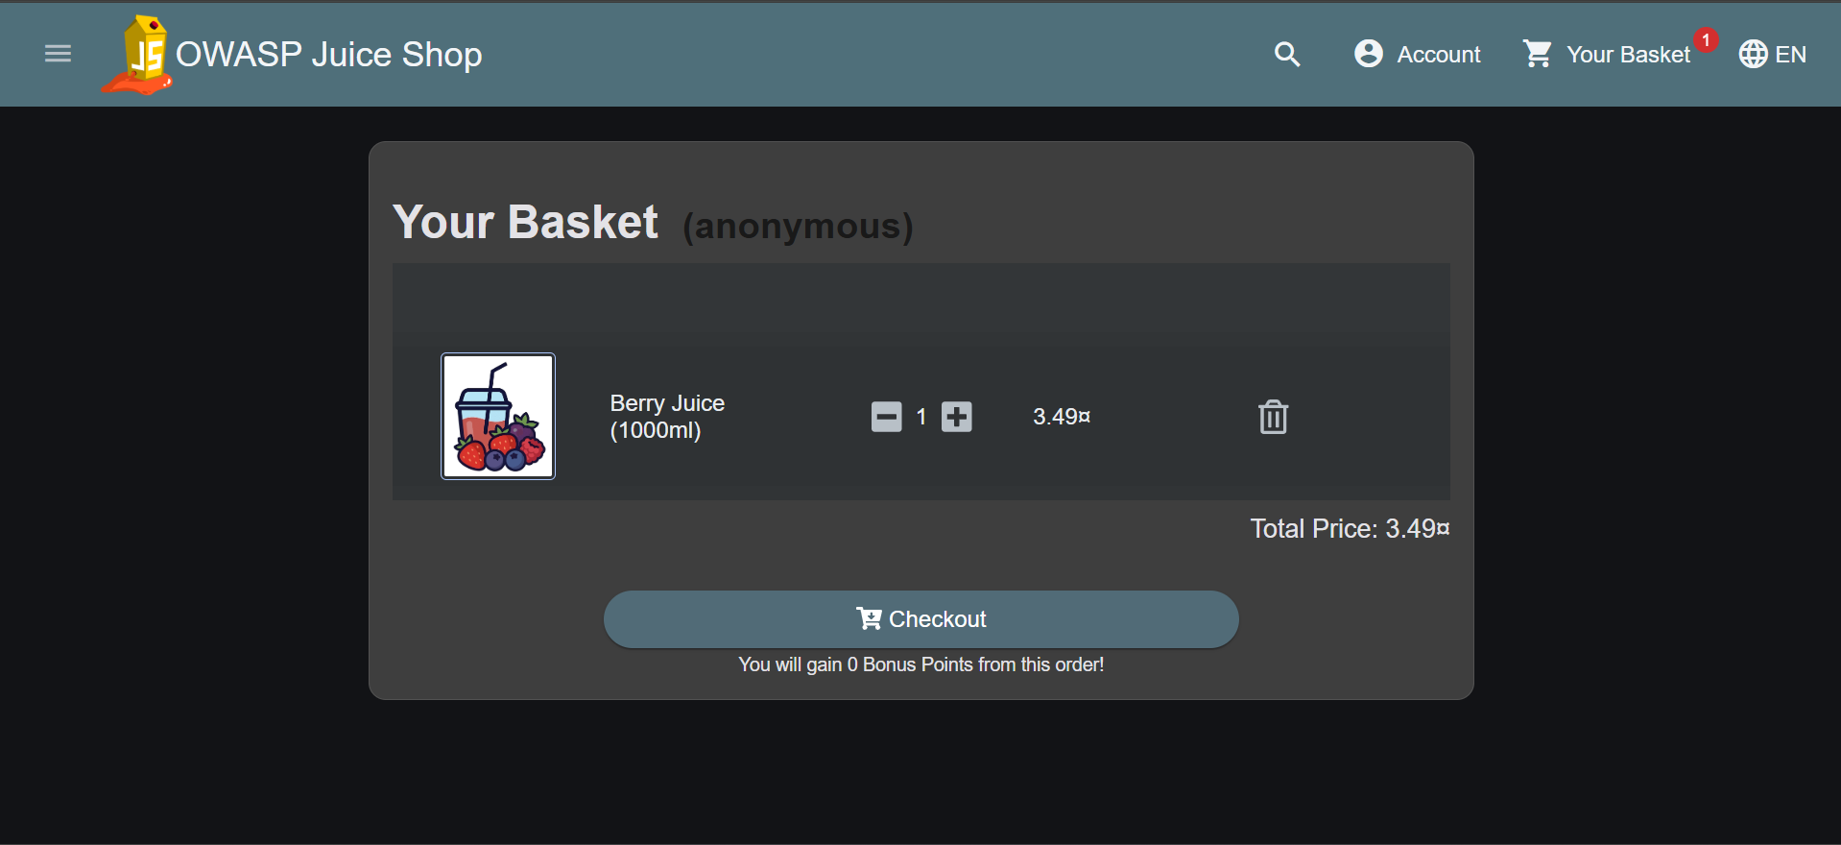
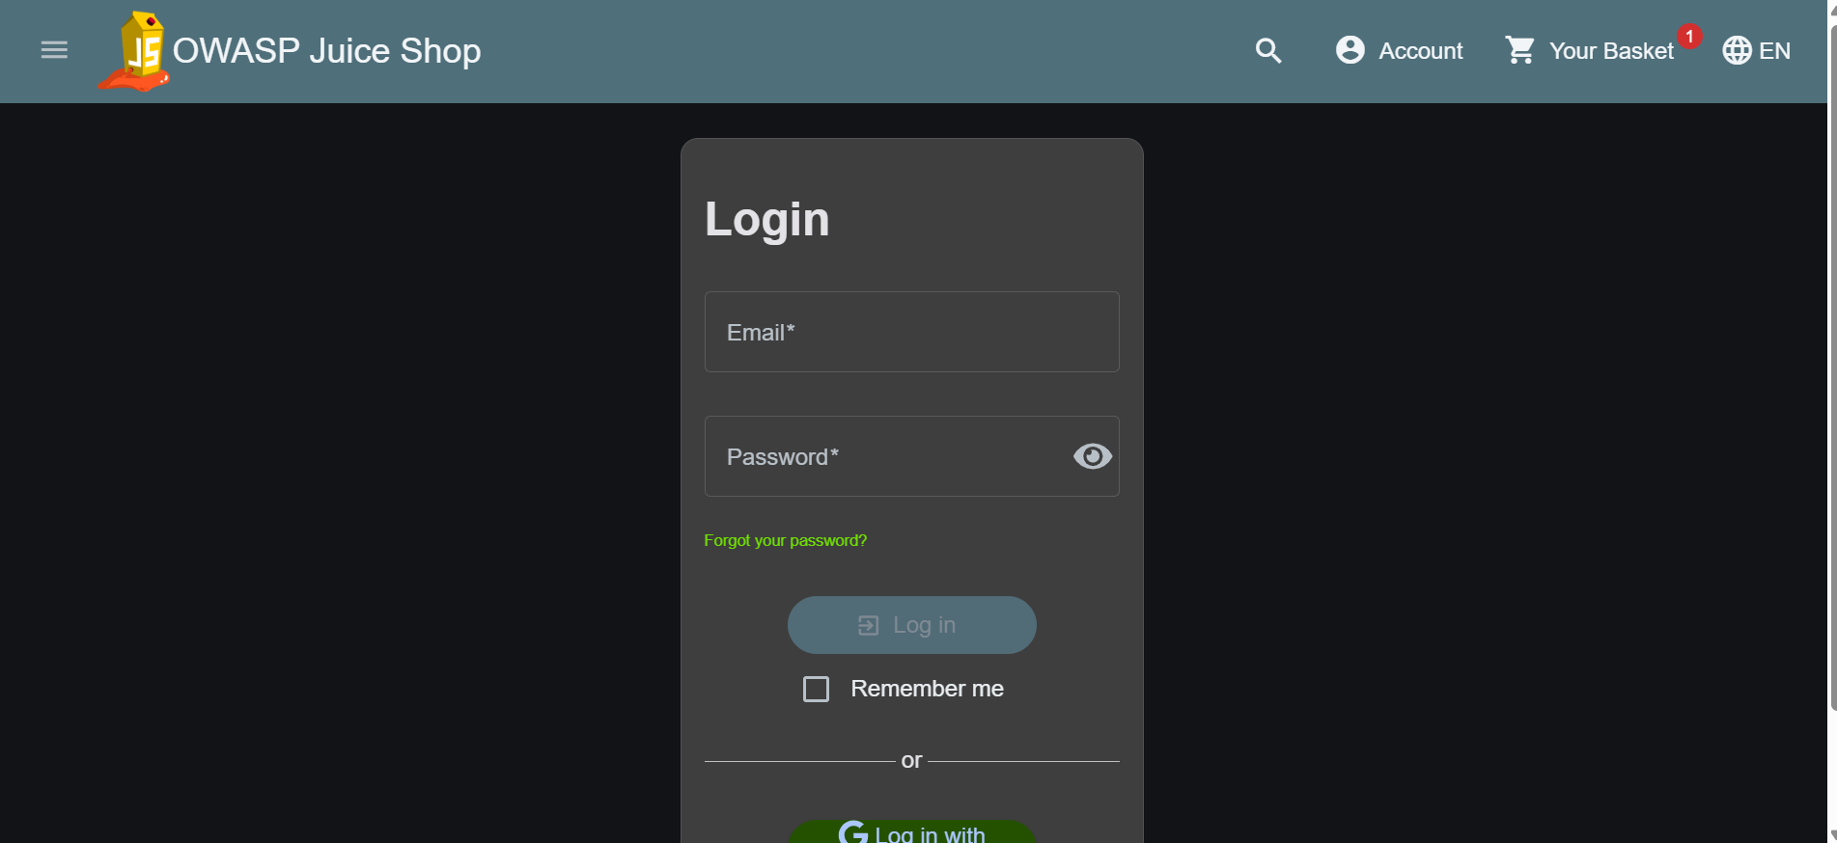
Figure3-Unable to checkout due to lack of login

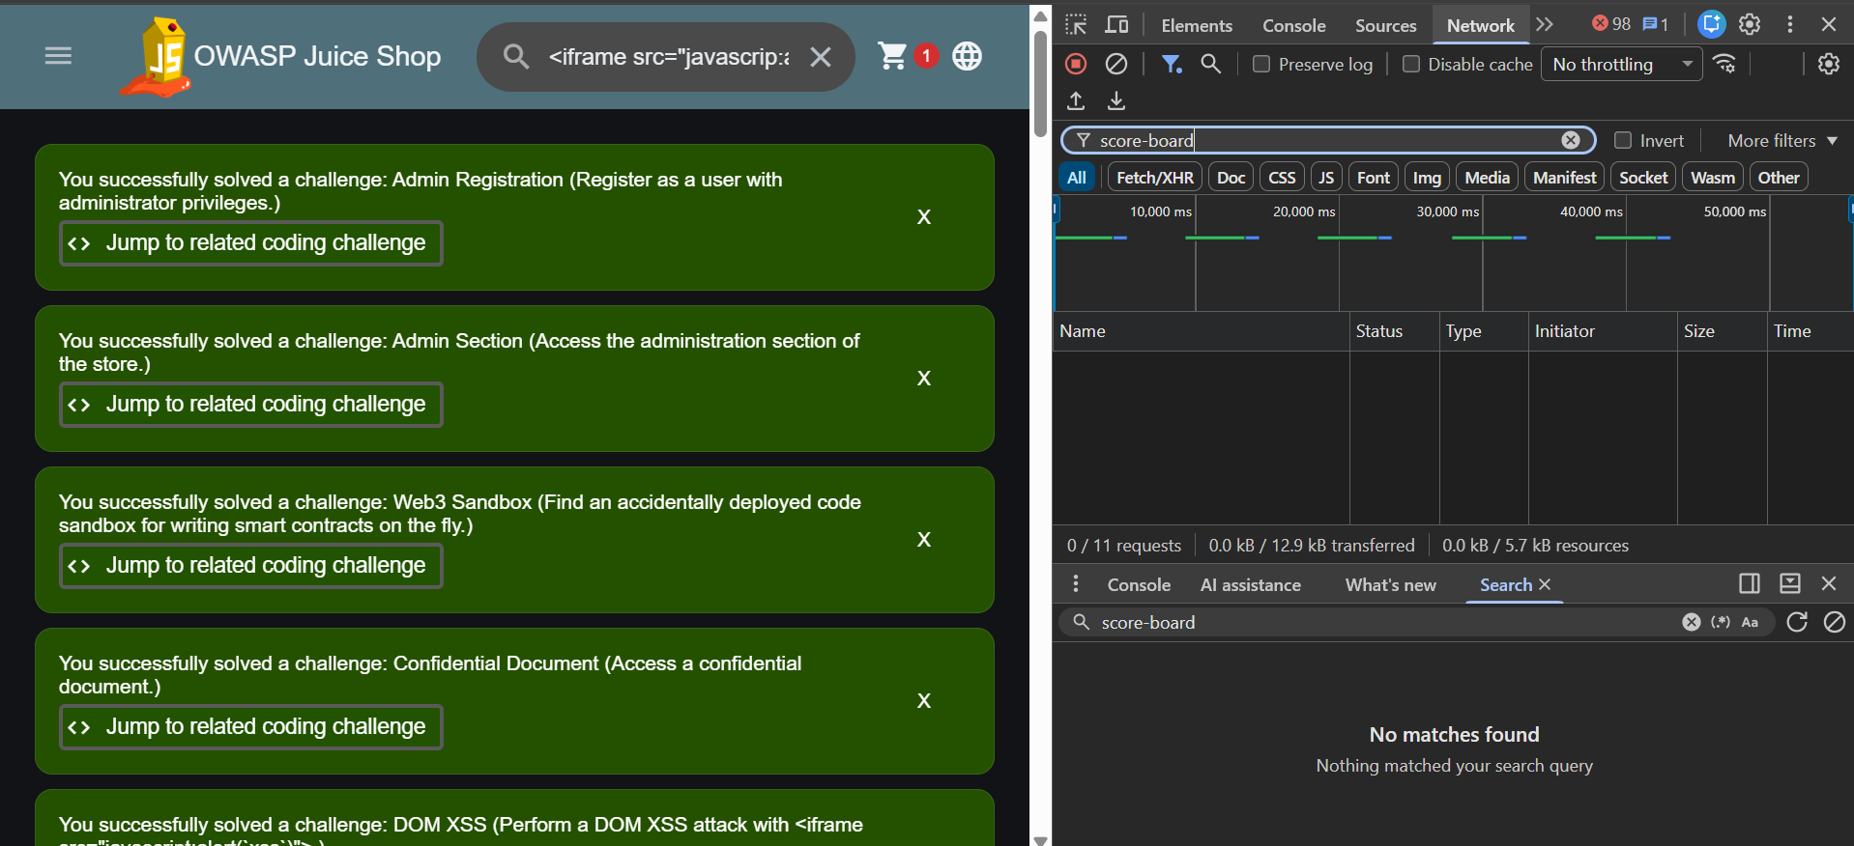
Figure4-Challenge Dashboard

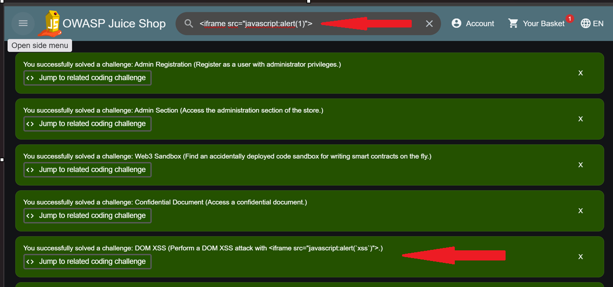
Figure5-DOM XSS

ATTACK SURFACE ASSESSMENT

An Attack Surface Assessment is a core component of a security evaluation. It maps out all potential entry points, vulnerabilities, and exposures that an attacker could attempt to exploit across an organization's digital ecosystem.

Here is a template and overview for a client-ready Attack Surface Assessment Report section.

Sample Report Section: Attack Surface Assessment

1. Overview & Objectives
The goal of an Attack Surface Assessment is to analyze an organization's external and internal environments to identify, quantify, and categorize all assets accessible to unauthorized users. By understanding the breadth of the attack surface, security teams can prioritize defensive controls and reduce overall operational risk.

2. Attack Surface Categorization

Total Attack Surface

➢External / Public Digital Assets
➢ Internal Network & Identity
➢ Human & Social Vector Surface

Digital External Surface: Publicly accessible IP addresses, domain names, cloud infrastructure, web applications, and exposed APIs.

Internal & Identity Surface: Active Directory architectures, internal subnets, network shares, service accounts, and privilege structures.

Third-Party & Supply Chain Surface: Vendor connections, integrated SaaS applications, open-source software dependencies, and partner APIs.

Human Surface: Exposed employee contact details, public code commits, and social media footprints susceptible to social engineering.

Digital External Surface: Publicly accessible IP addresses, domain names, cloud infrastructure, web applications, and exposed APIs.

- Internal & Identity Surface: Active Directory architectures, internal subnets, network shares, service accounts, and privilege structures.
- Third-Party & Supply Chain Surface: Vendor connections, integrated SaaS applications, open-source software dependencies, and partner APIs.
- Human Surface: Exposed employee contact details, public code commits, and social media footprints susceptible to social engineering.

3. Summary of Identified Exposures
Surface Area | Key Findings / Exposures | Business Impact | Risk Level
Public Applications | Unpatched third-party libraries and exposed legacy REST endpoints. | Increased risk of web application compromise or data leakage. | High
Cloud Infrastructure | Storage buckets with permissive access policies; unassigned elastic IPs. | Cloud asset takeover, unauthorized data exposure, or resource hijacking. | Medium
Network Perimeter | Non-standard administrative ports (e.g., SSH, RDP) open to the internet. | Brute-force and unauthorized remote access attempts. | High
Information & Metadata | Detailed technical stack details disclosed in HTTP response headers. | Provides target details for tailored exploit selection. | Low

4. Key Strategic Recommendations
To effectively reduce and manage the attack surface over time:

- Implement Continuous Discovery: Deploy Continuous Threat Exposure Management (CTEM) tools to automatically discover new subdomains, cloud instances, and open ports as they are provisioned.

- Enforce Zero Trust Access: Restrict administrative interfaces and non-public services behind strict Multi-Factor Authentication (MFA) and Zero Trust Network Access (ZTNA) solutions rather than direct internet access.

- Harden Perimeter Configurations: Remove unused services, disable verbose server headers (X-Powered-By, Server), and enforce strict access control policies on cloud storage assets.

- Manage Software Dependencies: Regularly audit open-source packages using Software Composition Analysis (SCA) to identify and patch known CVEs before deployment.

OWASP RISK MAPPING

An OWASP Risk Mapping aligns an application’s specific security findings to the OWASP Risk Rating Methodology and the OWASP Top 10. This framework evaluates risk based on Likelihood (how easy it is to exploit) and Impact (how severe the business damage is).
Below is a client-ready overview and structured template for an OWASP Risk Mapping section in a security assessment report.

1. The OWASP Risk Rating Methodology
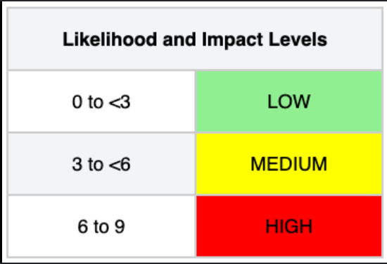

─────────┐
│ LIKELIHOOD FACTORS │
│ Threat Agent + Vulnerability│
└─────────────┬─────────────┘

Risk Calculation Matrix
Likelihood | Low Impact | Medium Impact | High Impact
High | Medium | High | CRITICAL
Medium | Low | Medium | High
Low | Informational | Low | Medium

2. Findings Mapping to OWASP Top 10
Below is an example mapping of common technical findings (such as those found in environments like OWASP Juice Shop) to the OWASP Top 10 categories:
OWASP Top 10 Category | Specific Technical Finding | Likelihood | Technical / Business Impact | Overall Risk Level
A01:2021 – Broken Access Control | Insecure Direct Object References (IDOR) on User Orders API | High | Unauthenticated viewing/modifying of other users' personal cart data. | CRITICAL
A03:2021 – Injection | SQL Injection in Search/Login Input Fields | High | Database compromise, complete administrative access bypass, data exfiltration. | CRITICAL
A02:2021 – Cryptographic Failures | Weak password hashing (MD5) & cleartext transmission of API tokens | Medium | Credential cracking, session interception via network eavesdropping. | High
A07:2021 – Identification & Auth Failures | Lack of rate limiting on login & password reset endpoints | High | Credential stuffing, brute-force account takeover attacks. | High
A05:2021 – Security Misconfiguration | Verbose error stack traces and unhandled API exceptions exposed | High | Discloses internal framework paths, libraries, and database schemas. | Medium
A06:2021 – Vulnerable & Outdated Components | Unpatched third-party npm libraries containing known CVEs | Medium | Varies by CVE (ranging from Denial of Service to Remote Code Execution). | Medium / High

3. Remediation Prioritization Based on OWASP Risk
To address these findings effectively, prioritize remediation efforts using the following tier structure:
- Immediate Action (Critical Risk): Fix Broken Access Control (A01) and Injection (A03) vulnerabilities immediately. These represent direct pathways to full application and data compromise with minimal effort required from attackers.
- Short-Term (High Risk): Implement strong password hashing (e.g., Argon2, bcrypt), enforce JWT signature checks (A02), and apply rate-limiting across authentication endpoints (A07).
- Medium-Term (Medium Risk): Suppress verbose server error outputs (A05) and establish automated Software Composition Analysis (SCA) scanners to keep dependencies updated (A06).

-:RISK REGISTER:-

A Risk Register is a centralized security governance document used to log, track, and manage security vulnerabilities and business risks identified during assessments (such as penetration tests or audits). It translates technical findings into actionable business risk items, assigns ownership, and tracks remediation progress over time.
Here is a client-ready Risk Register Template & Example tailored to a web application security assessment (such as an OWASP Juice Shop evaluation).

1. Key Fields in a Cybersecurity Risk Register
A comprehensive Risk Register captures both technical details and governance metadata:
➢Risk ID: Unique identifier for tracking (e.g., RSK-2026-001).
➢Asset / Component: The system, API endpoint, or database affected.
➢Vulnerability & Threat: What the flaw is and how an attacker could exploit it.
➢OWASP / Framework Mapping: Reference to industry standards (e.g., OWASP Top 10, NIST).
➢Inherent Risk: The severity level before any controls or fixes are applied.
➢Remediation Action: Specific engineering steps required to resolve the risk.
➢Risk Owner: The individual or team responsible for applying the fix.
➢Target Date: Agreed-upon deadline based on SLA/severity policy.
➢Status: Current state (Open, In Progress, Risk Accepted, Closed).

2. Sample Application Security Risk Register
Risk ID | Asset / Component | Vulnerability / Threat Description | OWASP Mapping | Inherent Risk | Mitigation Strategy | Owner | Target Date | Status
RSK-01 | /rest/user/login API | SQL Injection: Unsanitized user inputs allow authentication bypass and DB access. | A03:2021 Injection | CRITICAL | Implement parameterized queries (prepared statements) across all DB calls. | Backend Team | 7 Days | In Progress
RSK-02 | Customer Basket API | IDOR / Broken Access Control: Users can view or modify other users' order carts. | A01:2021 Broken Access Control | CRITICAL | Enforce session-based authorization checks on server-side request parameters. | API Team | 7 Days | Open
RSK-03 | Auth Subsystem | Weak Password Hashing: User passwords stored using legacy MD5 algorithm. | A02:2021 Cryptographic Failures | HIGH | Upgrade password hashing scheme to Argon2id or bcrypt with high work factor. | Security Eng | 14 Days | In Progress
RSK-04 | Admin Portal | Missing Rate Limiting: Login endpoints lack brute-force protection. | A07:2021 Identification Failures | HIGH | Implement IP-based and account-based rate limiting via API Gateway middleware. | DevOps / Sec | 14 Days | Open
RSK-05 | Web Server / HTTP | Verbose Error Logs: Full application stack traces returned on 500 internal errors. | A05:2021 Security Misconfiguration | MEDIUM | Configure generic error handlers for production build environments. | Frontend Team | 30 Days | Closed

3. Standard Risk Remediation SLAs
Organizations typically define strict Service Level Agreements (SLAs) for addressing items in the Risk Register based on inherent severity:
- Critical Risk: Must be resolved within 7 days (or immediate virtual patching via WAF).
- High Risk: Must be resolved within 14–30 days.
- Medium Risk: Must be resolved within 60–90 days.
- Low / Informational: Resolved during standard sprint cycles or accepted as low operational risk.

4. Risk Treatment Options
When reviewing items on the register, management must choose one of four formal risk treatment decisions:
- Mitigate (Remediate): Apply code fixes, patches, or architectural changes to eliminate the flaw.
- Accept: Acknowledge the risk when the cost of fixing exceeds the potential impact (requires formal CISO/Leadership sign-off).
- Transfer: Shift the financial or operational risk to a third party (e.g., cyber insurance, hosted cloud provider).
- Avoid: Eliminate the high-risk feature or component entirely from the application.

-:RECOMMENDATIONS:-
In a security assessment report, the Recommendations section bridges the gap between technical risk identification and actionable remediation. It provides leadership and engineering teams with prioritized, concrete steps to fix vulnerabilities, harden application architecture, and prevent recurring flaws.

Detailed Remediation Plan

1. High-Priority / Immediate Action (Critical Risks)
Goal: Eliminate direct pathways to data exfiltration and account takeover.
- Enforce Parameterized Database Queries:
Replace all concatenated dynamic SQL statements with parameterized queries (prepared statements) or Object-Relational Mapping (ORM) abstractions across all API endpoints to completely eliminate SQL Injection (SQLi).
- Implement Server-Side Authorization Checks:
Enforce strict, server-side authorization validation for every object access request. Do not rely on client-supplied IDs (e.g., basketId, userId) without verifying that the authenticated session owns the requested resource to block Insecure Direct Object References (IDOR).
- Neutralize Cross-Site Scripting (XSS):
Implement contextual output encoding and input sanitization on all user-controlled inputs rendered in the DOM. Deploy a strict Content Security Policy (CSP) header to prevent unauthorized inline script execution.

2. Medium-Priority / Short-Term Action (High & Medium Risks)
Goal: Strengthen authentication, session integrity, and system configuration.
- Upgrade Cryptographic Algorithms & JWT Validation:
Migrate password storage from legacy hashing algorithms (e.g., MD5/SHA-1) to salted Argon2id or bcrypt with an appropriate work factor. Enforce explicit signature algorithm verification on all JSON Web Tokens (JWT) on the server side to prevent token tampering.
- Implement Rate Limiting & Account Protection:
Deploy rate-limiting middleware (or utilize API Gateway policies) on sensitive endpoints (login, password reset, checkout APIs) to protect against brute-force attacks and automated credential stuffing.
- Harden Environment Configurations:
Disable verbose error stack traces in production builds. Configure global error-handling logic to return generic HTTP status codes (500 Internal Server Error) to the client while routing full diagnostic traces to secure internal logging.

3. Long-Priority / Strategic Action (Low Risks & Process Improvements)
Goal: Shift security left to prevent future vulnerabilities during development.
- Automate Security Scans in CI/CD (DevSecOps):
Integrate SAST (Static Application Security Testing) tools (e.g., SonarQube, Semgrep) and SCA (Software Composition Analysis) scanners (e.g., Snyk, Dependency-Check) directly into build pipelines to block vulnerable dependencies and code flaws before deployment.
- Adopt a Zero-Trust & Least-Privilege Model:
Restrict access to internal administrative dashboards, database tools, and staging environments using Zero-Trust Network Access (ZTNA) or strict IP allowlisting rather than public internet accessibility.
- Conduct Interactive Developer Security Training:
Provide developers with practical, hands-on training using platforms like OWASP Juice Shop to build familiarity with secure coding practices, common attack vectors, and effective code-level remediation.

Action Items Summary Table
Category | Recommended Control / Fix | Primary Target Flaw | Target SLA
Architecture | Parameterized queries & ORM enforcement | SQL Injection (A03) | 7 Days
Access Control | Server-side session verification | IDOR & Broken Access Control (A01) | 7 Days
Cryptography | Upgrade password hashing to Argon2id / bcrypt | Cryptographic Failures (A02) | 14 Days
Authentication | Rate limiting + mandatory JWT signature checks | Auth & Identification Failures (A07) | 14 Days
Configuration | Suppress verbose stack traces & strip debug files | Security Misconfiguration (A05) | 30 Days
Process | Implement automated SAST/SCA in CI/CD pipeline | Vulnerable Components (A06) | 60 Days

-:CONCLUSION:-

The security assessment and penetration testing of the OWASP Juice Shop web application successfully demonstrated the real-world impact of common security flaws defined in the OWASP Top 10. By systematically evaluating the application’s attack surface, key vulnerabilities were identified and exploited across multiple categories, including:
- Injection Flaws (SQLi/NoSQLi): Demonstrating how unvalidated user inputs allow unauthorized database queries, account takeovers, and potential data leaks.

- Broken Authentication & Access Control: Highlighting how weak password policies, improper session management, and Insecure Direct Object References (IDOR) can grant attacker administrative privileges or unauthorized access to sensitive user profiles.

- Cross-Site Scripting (XSS): Exposing how improper input sanitization and missing client-side controls allow execution of malicious scripts to hijack user sessions.

- Security Misconfigurations: Revealing verbose error responses, unencrypted data transmissions, exposed sensitive files, and missing security headers (e.g., CSP, HSTS).

Key Takeaways & Recommendations
While OWASP Juice Shop is intentionally designed to be insecure for educational purposes, the flaws identified reflect severe risks that frequently impact production web applications. To mitigate similar vulnerabilities in a production environment, the following defensive strategies are essential:

- Strict Input Validation & Sanitization: Enforce parameterized queries (prepared statements) for all database operations and sanitize inputs contextually to prevent injection and XSS attacks.
- Robust Authentication & Access Management: Implement multi-factor authentication (MFA), enforce strong password policies, and apply strict Server-Side Authorization checks for every API request.

- Hardened Security Configurations: Strip sensitive metadata from server responses, configure restrictive Content Security Policies (CSP), and enforce HTTPS via HSTS headers across all endpoints.

- DevSecOps Integration: Incorporate automated static/dynamic security testing (SAST/DAST) into the Continuous Integration/Continuous Deployment (CI/CD) pipeline to catch flaws prior to deployment.

Final Summary
Overall, this project provided valuable practical experience in identifying software weaknesses, understanding the perspective of an attacker, and applying defense-in-depth principles. Addressing these vulnerabilities through proper secure-coding practices, regular code reviews, and continuous security monitoring is critical to maintaining a robust security posture against modern cyber threats.

